Statistics Library Documentation

Program Overview
A Java-based statistical calculation program for computing basic statistics and probability distributions.

Features

Basic Statistics
- Mean
- Median
- Mode
- Standard Deviation

Probability Calculations
- Combinations (nCr)
- Permutations (nPr)
- Binomial Probability
- Geometric Probability
- Hypergeometric Probability
- Negative Binomial Probability

Class Details

StatsLibrary.java

Statistical Methods:
getMean(): Calculates average
getMedian(): Finds middle value
getMode(): Finds most frequent value
getStandardDeviation(): Calculates spread
Probability Methods:
calculateCombination(n, r): Computes nCr
calculatePermutation(n, r): Computes nPr
calculateBinomial(n, r, p): Binomial probability
calculateGeometric(p, r): Geometric probability
calculateHypoGeometric(N, K, n, k): Hypergeometric probability
calculateNegativeBinomial(y, r, p): Negative binomial probability

Usage Examples
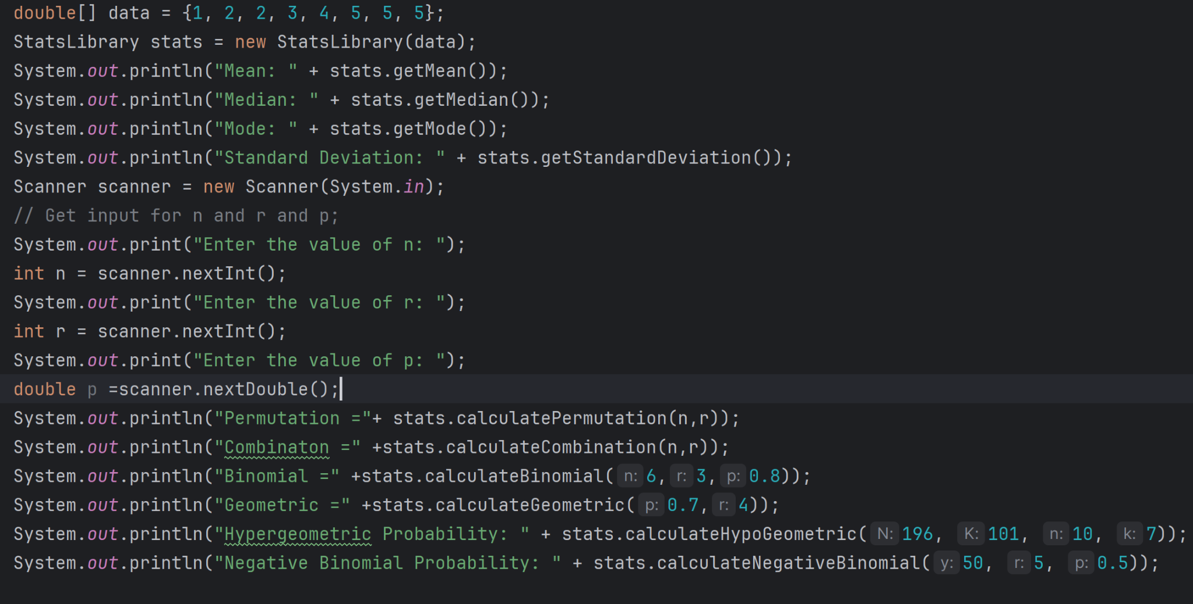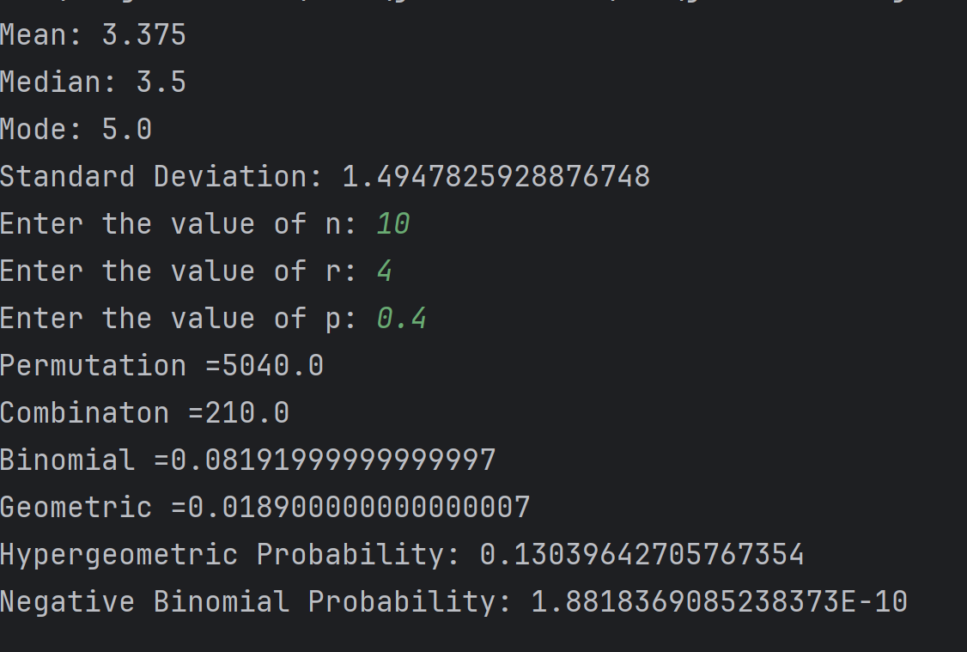

Independent Intersection: Calculates the probability that both events occur assuming they are independent.
Dependent Intersection: Calculates the probability that both events occur assuming one is dependent on the other.
Exclusive Union: Computes the probability that either event occurs, excluding their intersection.
Non-Exclusive Union: Computes the probability that either event occurs, including their intersection.
Independence Check: Verifies if the events are independent based on given probabilities.
Dependence Check: Verifies if the events are dependent based on given probabilities.
Example:
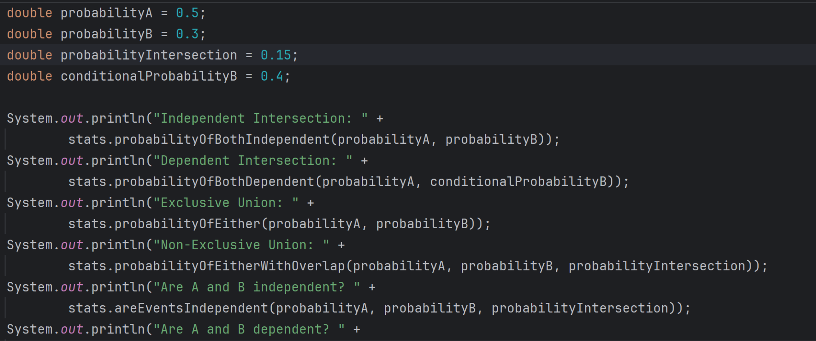

Output

